**Detecting Parkinsons Disease using Machine Learning**

**ASSIGNMENT - 2**

|  |  |
| --- | --- |
| Date | 26th September 2022 |
| Team ID | PNT2022TMID27836 |
| Student Name | Prabhakaran M (311519104044) |
| Domain Name | Healthcare |
| Project Name | Detecting Parkinsons Disease using Machine Learning |
| Maximum Marks | 2 Marks |

**1.)IMPORT THE REQUIRED LIBRARIES**



**2.)DOWNLOAD AND UPLOAD THE DATASET**

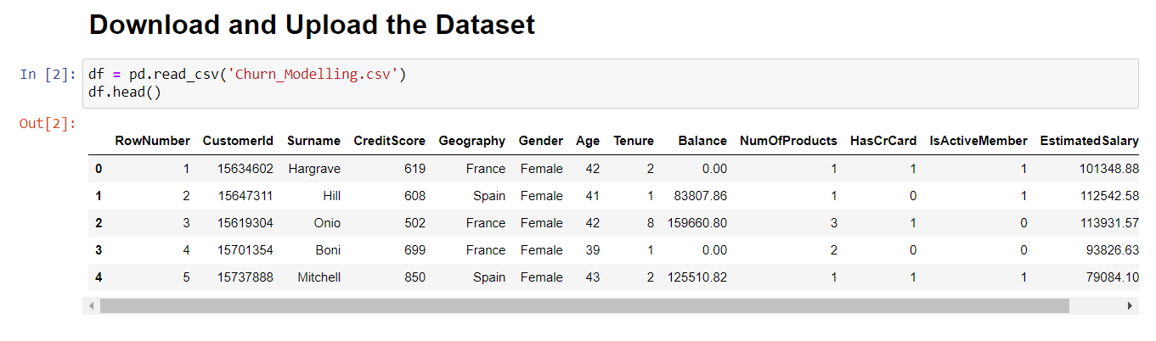

**3.)HANDLE MISSING VALUES IN THE DATASET**

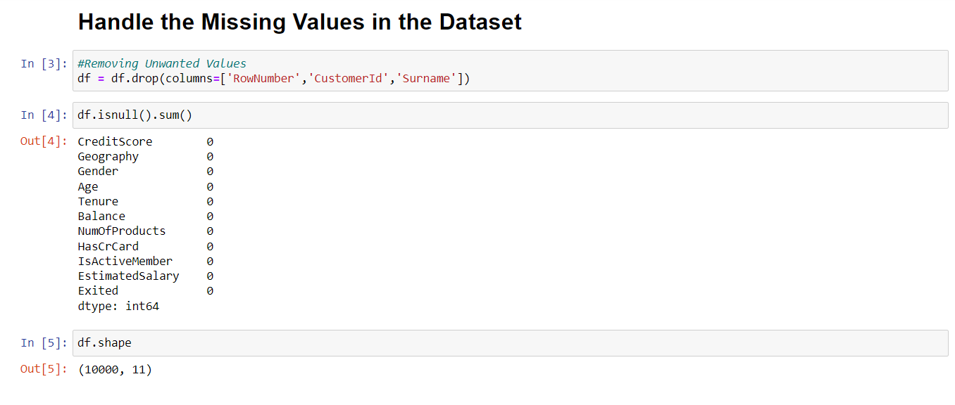

**4.) PERFORM THE DESCRIPTIVE STATISTICS ON THE DATASET**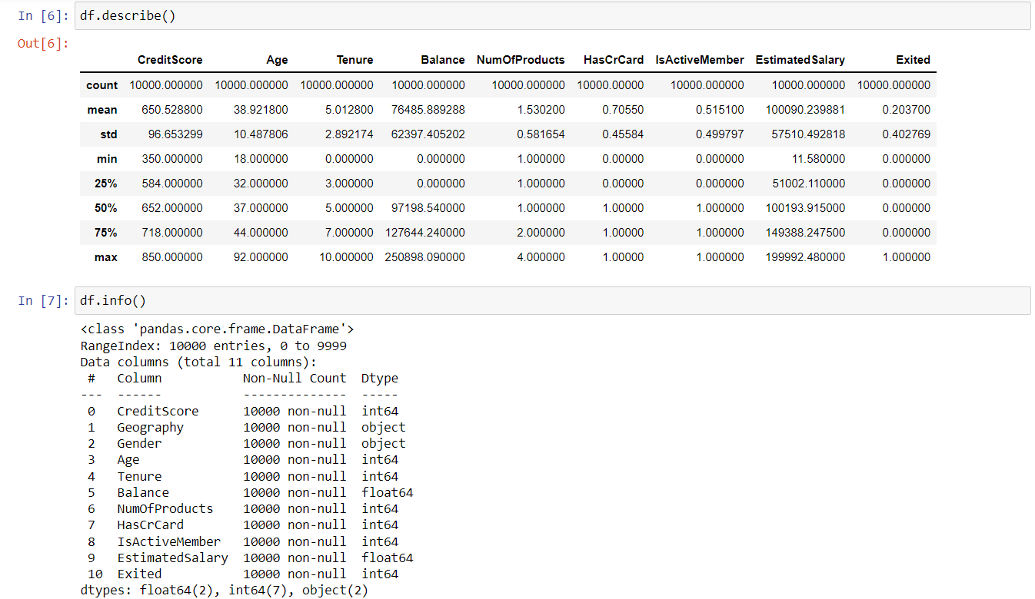

**5.) PERFORM VARIOUS VISUALISATIONS**

**a.) UNIVARIANTE ANALYSIS**

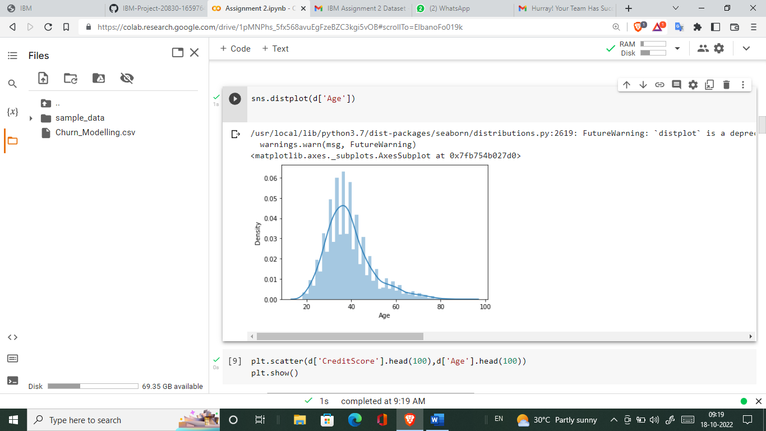

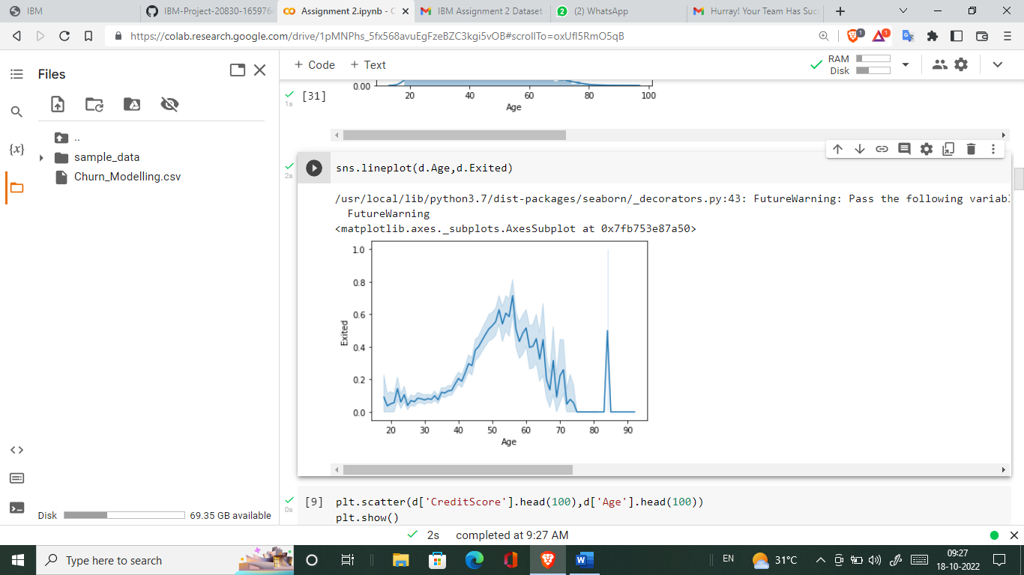

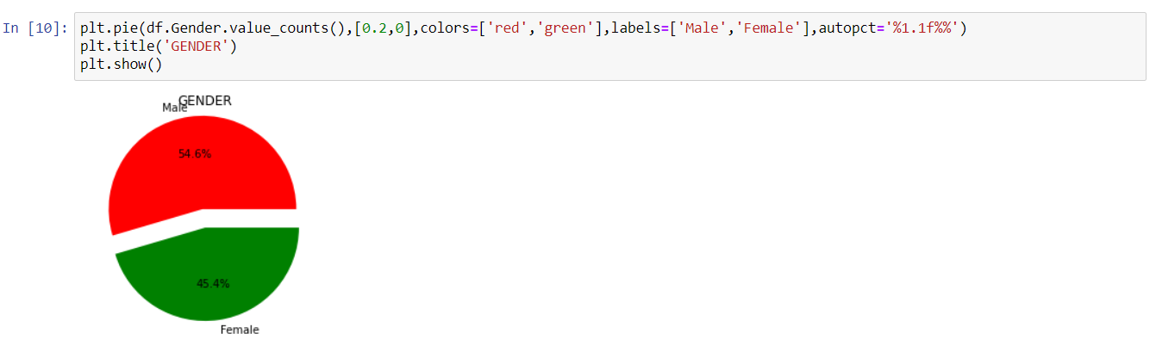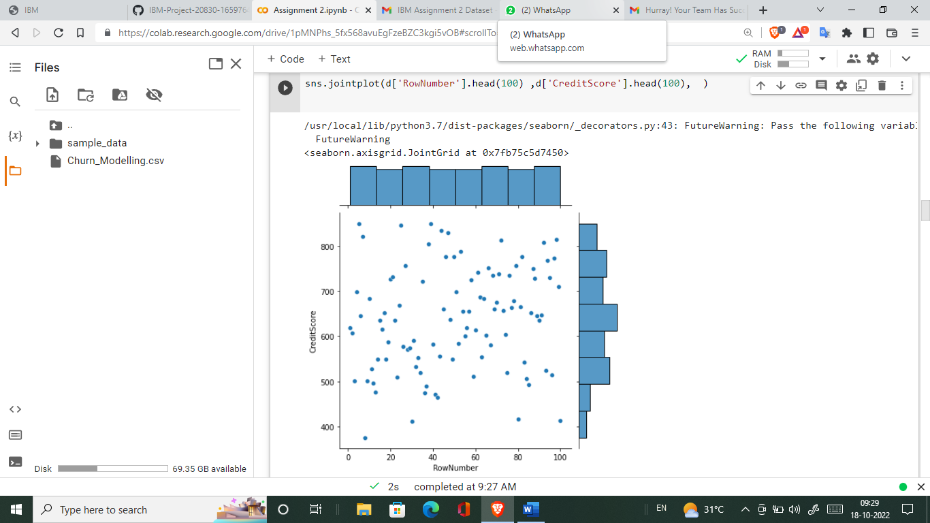

**b.) BI - VARIANTE ANALYSIS**

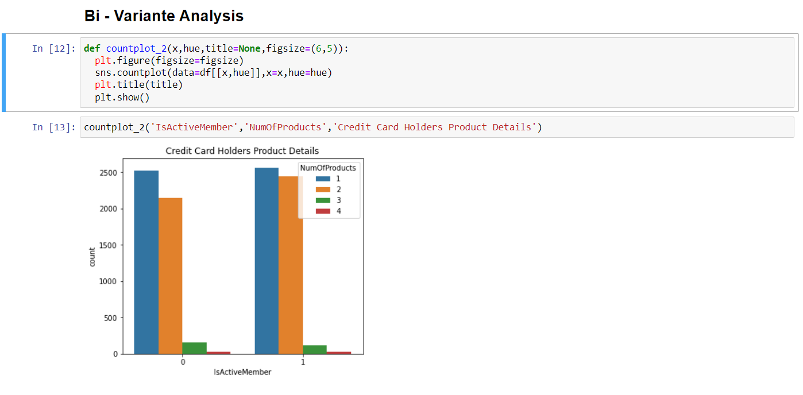

**c.) MULTI - VARIANTE ANALYSIS**

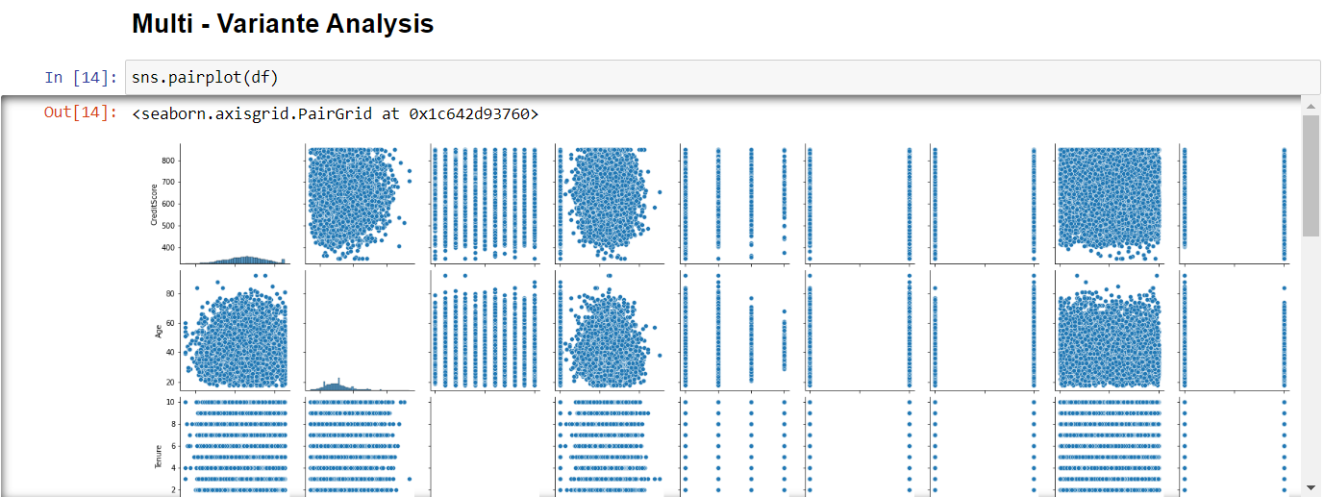

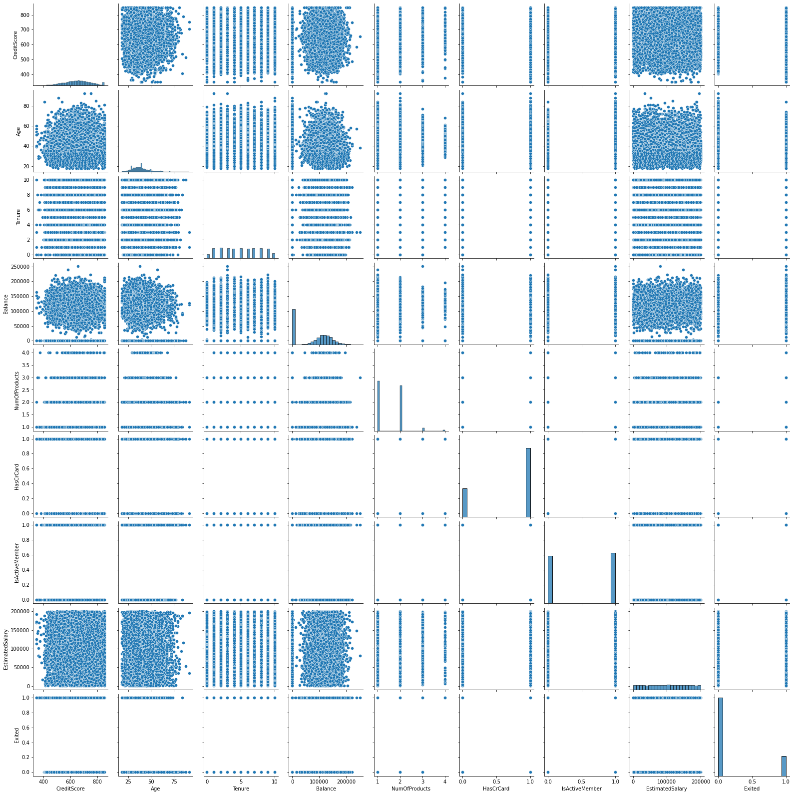

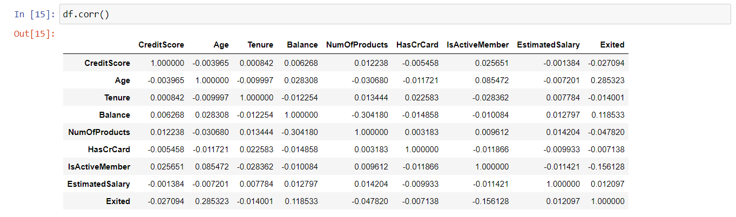

**6.) FIND AND REPLACE THE OUTLIERS**

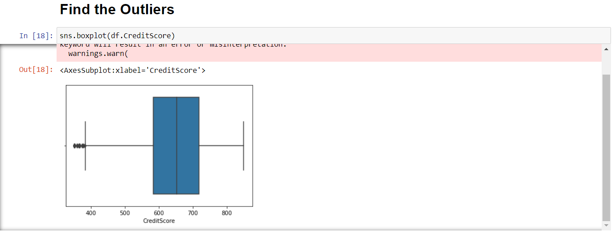

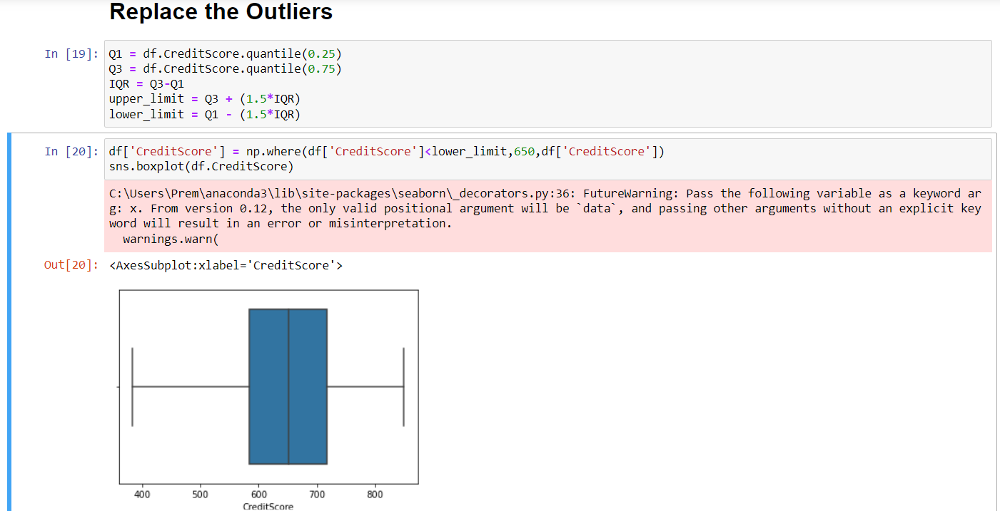



**7.) CHECK FOR CATEGORICAL COLUMNS AND ENCODE THEM**

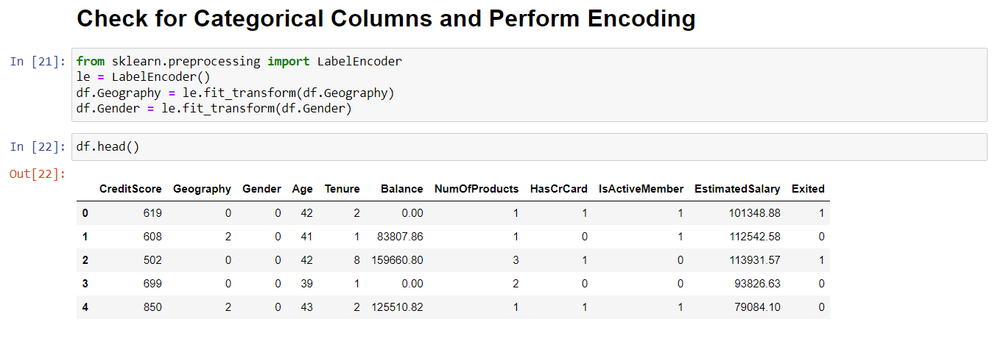

**s**

**8.)SPLIT DATA INTO DEPENDENT AND INDEPENDENT VARIABLES**

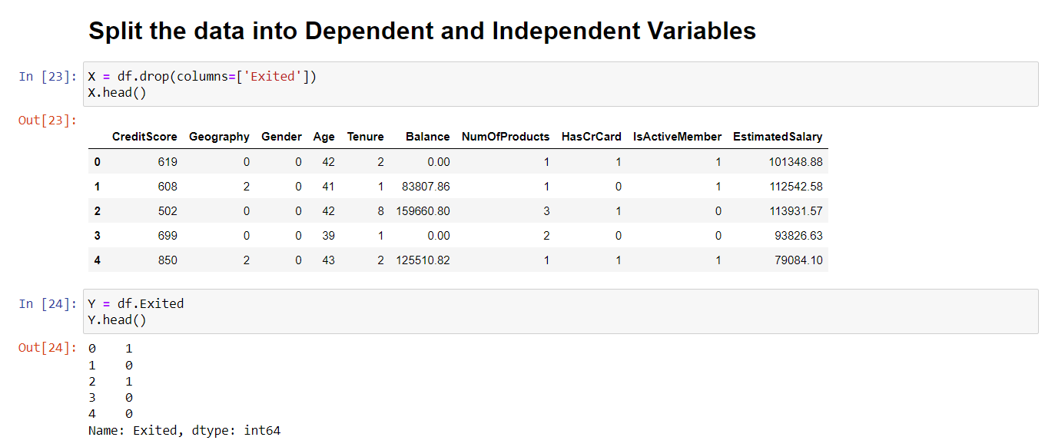

**9.) SCALE THE INDEPENDENT VARIABLES**

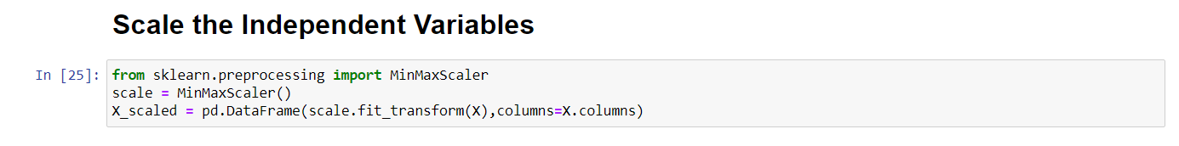

**10.)SPLIT THE DATA INTO TRAINING AND TESTING**

